**COOK BOOK: YOUR VIRTUAL KITCHEN ASSISTANT – PROJECT DOCUMENTATION**

1. INTRODUCTION

Project Title:

Cookbook: Your Virtual Kitchen Assistant

Team Leader:

Prashanthini Nagarajan

Team Members:

1. Prabhu M
2. Karanraj C
3. Poovarasan K

2. PROJECT OVERVIEW

Purpose:

Cookbook is a React.js-based web app designed to be your personal kitchen helper. It lets you explore, add, and manage recipes easily, plan your meals, and create shopping lists — all in one place. The goal is to make cooking simpler and more enjoyable by providing a clean, user-friendly interface.

Features:

* Browse a variety of recipes with search and filter options
* Add your own recipes and edit existing ones
* Plan your meals using an interactive calendar
* Generate shopping lists based on your meal plans
* User authentication to save and manage your profile

3. ARCHITECTURE

Component Structure:

The app is built with React components organized to keep things modular and easy to maintain:

* `App.js`: The root component that sets up routing and global state
* `Recipe List`: Displays all recipes with search and filter capabilities
* `Recipe Detail`: Shows detailed information about a selected recipe
* `Meal Planner`: A calendar interface for scheduling meals
* `Shopping List`: Generates shopping lists from planned meals
* `User Profile`: Allows users to manage their account and preferences

Components communicate through props and shared global state.

State Management:

The project uses Reacts Context API combined with `use Reducer` to manage global state efficiently without adding extra dependencies.

Routing:

React Router is used to handle navigation between pages:

* `/` – Home page with recipe listings
* `/recipe/:id` – Detailed recipe view
* `/planner` – Meal planner calendar
* `/shopping-list` – Shopping list page
* `/profile` – User profile and settings

4. SETUP INSTRUCTIONS

Prerequisites:

* Node.js (v14 or higher)
* npm (v6 or higher)

Installation Steps:

1. Clone the project repository:

https://github.com/prashanthininagarajan-lgtm/Cookbook

2. Navigate to the client directory:

```bash

cd COOK-BOOK-/client

```

3. Install dependencies:

```bash

npm install

```

4. Create a `. env` file in the `client` folder and add any necessary environment variables (e.g., API URLs).

5. FOLDER STRUCTURE

Client:

The React app is organized as follows:

```

client/

├── public/ # Static files like index.html and images

├── src/

│ ├── assets/ # Images, icons, fonts

│ ├── components/ # Reusable UI components (buttons, modals, inputs)

│ ├── pages/ # Page components (Recipe List, Recipe Detail, etc.)

│ ├── context/ # Context providers and reducers for state management

│ ├── hooks/ # Custom React hooks

│ ├── utils/ # Helper functions

│ ├── styles/ # CSS and styled-components

│ └── App.js # Root component

└── package. Json

```

Utilities:

* API helper functions for fetching data
* Custom hooks for local Storage syncing and other reusable logic

6. RUNNING THE APPLICATION

* To start the app locally, run this inside the `client` folder:

```bash

npm start

```

* Open your browser and go to `http://localhost:3000` to see the app in action.

7. COMPONENT DOCUMENTATION

Key Components:

`RecipeList`

Purpose: Displays a searchable list of recipes

Props:

* `recipes` (array) – List of recipe objects
* `onSelectRecipe` (function) – Callback when a recipe is clicked

`RecipeDetail`

* Purpose: Shows detailed recipe info including ingredients and instructions
* Props:
* `recipeId` (string) – ID of the recipe to display

`MealPlanner`

* + Purpose: Lets users schedule meals on a calendar
  + Props: None (uses global state)

Reusable Components:

* `Button` – Customizable buttons for various actions
* `Modal` – For dialogs and confirmations
* `Input` – Form inputs with validation

8. STATE MANAGEMENT

Global State:

Managed with React Context and `useReducer`, global state includes user info, recipes, meal plans, and shopping lists. This keeps the app data consistent and easy to update.

Local State:

Components use `useState` for temporary UI states like form inputs and modal visibility.

9. USER INTERFACE

* The UI is clean, modern, and responsive, designed to work well on both desktop and mobile devices.
* Highlights include:
* Recipe browsing with search and filters
* Detailed recipe pages with clear instructions
* Meal planner calendar for easy scheduling
* Shopping list with checkable items

10. STYLING

CSS Frameworks/Libraries:

The app uses Styled-Components for styling, allowing CSS to be written directly in JavaScript with support for dynamic theming.

Theming:

Supports light and dark modes, with user preferences saved for a personalized experience.

11. TESTING

Testing Strategy:

* Unit tests for components using Jest and React Testing Library
* Integration tests to verify component interactions
* Plans to add end-to-end tests with Cypress in the future

Code Coverage:

Jest’s coverage reports help ensure important parts of the app are well tested.

12. SCREENSHOTS OR DEMO

Coding: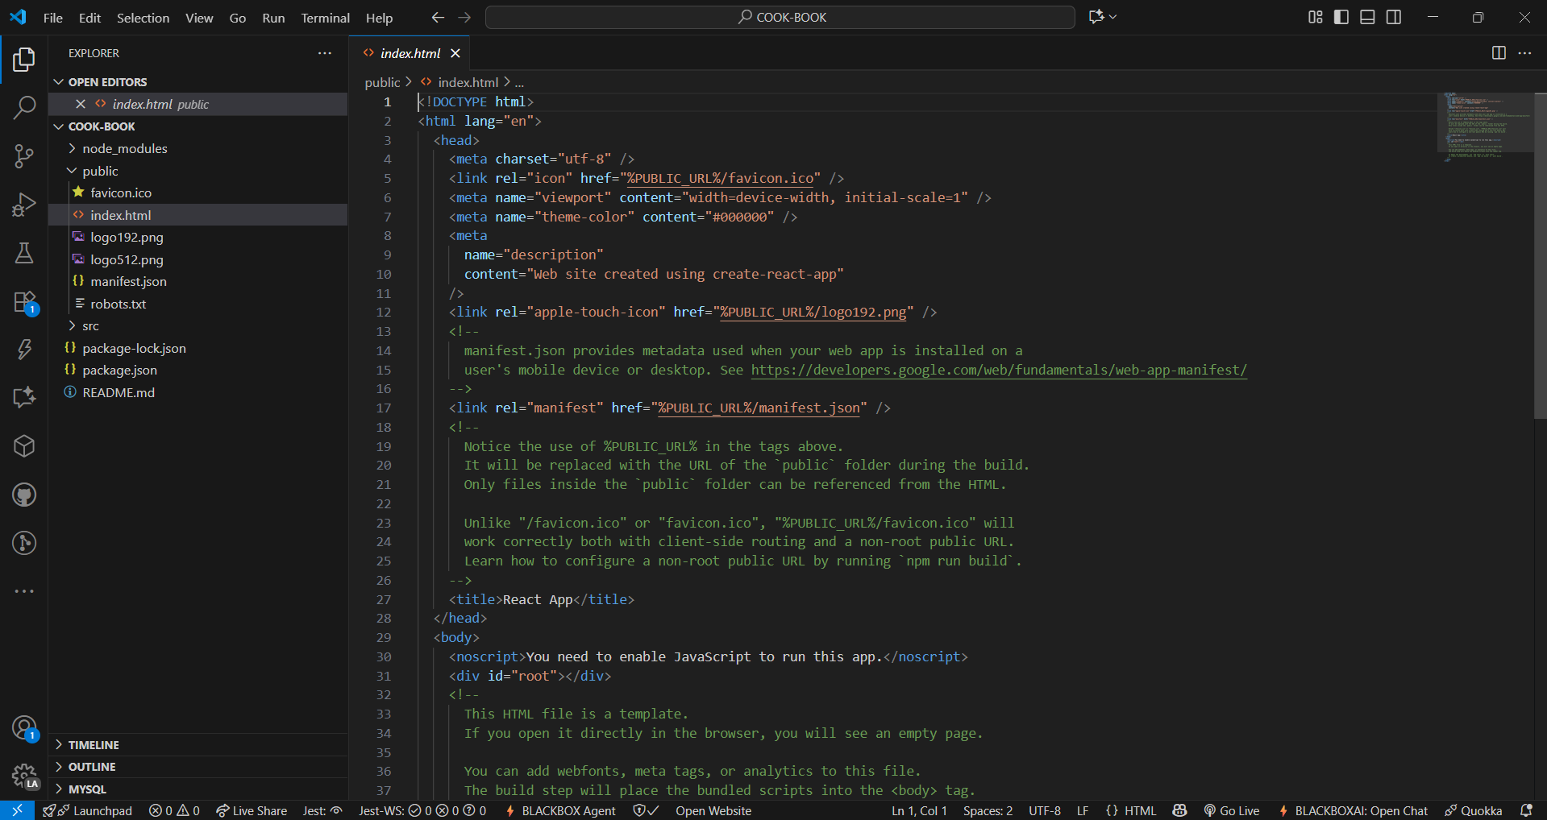

Output: 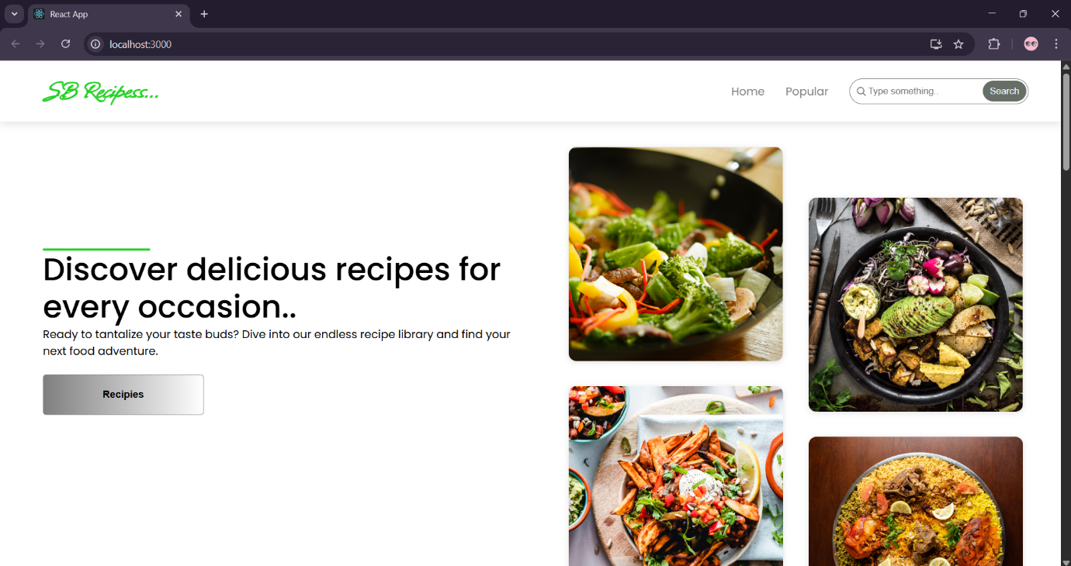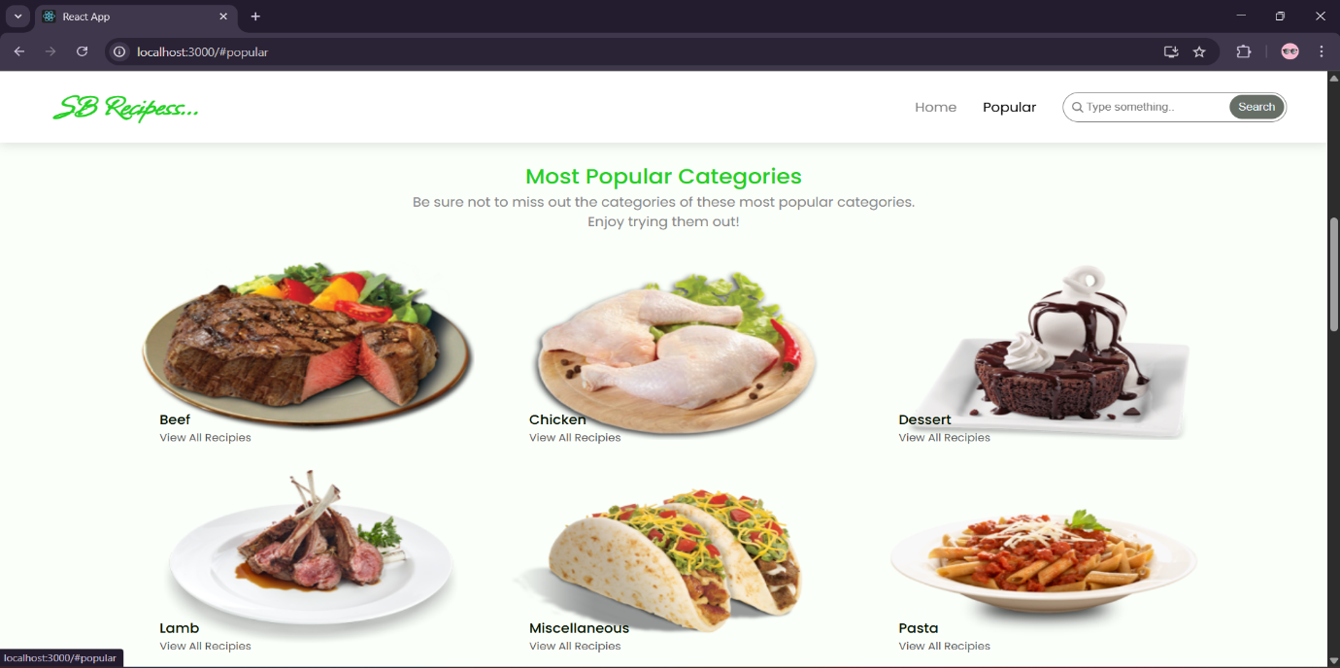

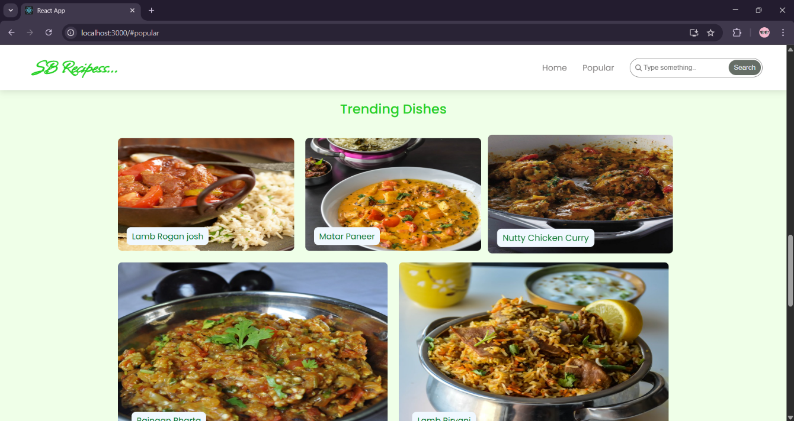

13. KNOWN ISSUES

* The meal planner calendar may sometimes not update immediately after adding a meal — refreshing the page fixes this.
* Some recipe images might fail to load if the source URL is broken.
* User profile updates can occasionally take a moment to reflect due to API response delays.

14. FUTURE ENHANCEMENTS

* Add social login options like Google and Facebook
* Implement offline support with service workers
* Add drag-and-drop functionality to the meal planner
* Include smooth animations for better user experience
* Expand testing with full end-to-end coverage using Cypress
* Add voice command support for hands-free navigation